LAB-4
Executive Summary
This report details the findings of a forensic analysis conducted on a suspected security breach. The investigation was initiated based on the provided Windows event logs and a network packet capture. The analysis revealed a targeted attack involving the Poison Ivy Remote Access Trojan (RAT), a well-known malware used for espionage and data theft. The attack originated from the IP address 192.168.134.129 and targeted the victim machine at 192.168.134.132. The primary attack vector appears to be a network-based intrusion, with the attacker establishing a command and control (C2) channel over TCP port 1241, the default port for Poison Ivy. The attacker conducted network reconnaissance, including extensive port scanning and SMB enumeration, indicating an attempt at lateral movement. The impact of this breach is considered high, with a significant risk to data confidentiality and system integrity. Immediate remediation actions are required to contain the threat and prevent further damage.
2. Investigation and Findings
2.1. Network Traffic Analysis
The network packet capture file, MaybeHackedBox--Capture.pcapng, contained 2,364 packets captured over a period of approximately 4 minutes. The analysis of this traffic revealed a significant amount of suspicious activity, as detailed below.
2.1.1. Poison Ivy RAT Communication
The most critical finding from the network analysis is the presence of traffic consistent with the Poison Ivy Remote Access Trojan (RAT). This is supported by the following evidence:
•High Volume of Traffic on Port 1241: A total of 1,305 TCP packets were observed on port 1241, which is the default C2 port for Poison Ivy 1. This accounted for the majority of the captured traffic.
•Persistent C2 Connection: A persistent TCP connection was established between the attacker's machine (192.168.134.129) and the victim's machine (192.168.134.132) on this port.
•Large Data Transfer: A significant amount of data was transferred over this connection, with approximately 1.7 MB of data sent from the attacker to the victim. This is indicative of malware payload delivery and remote command execution.

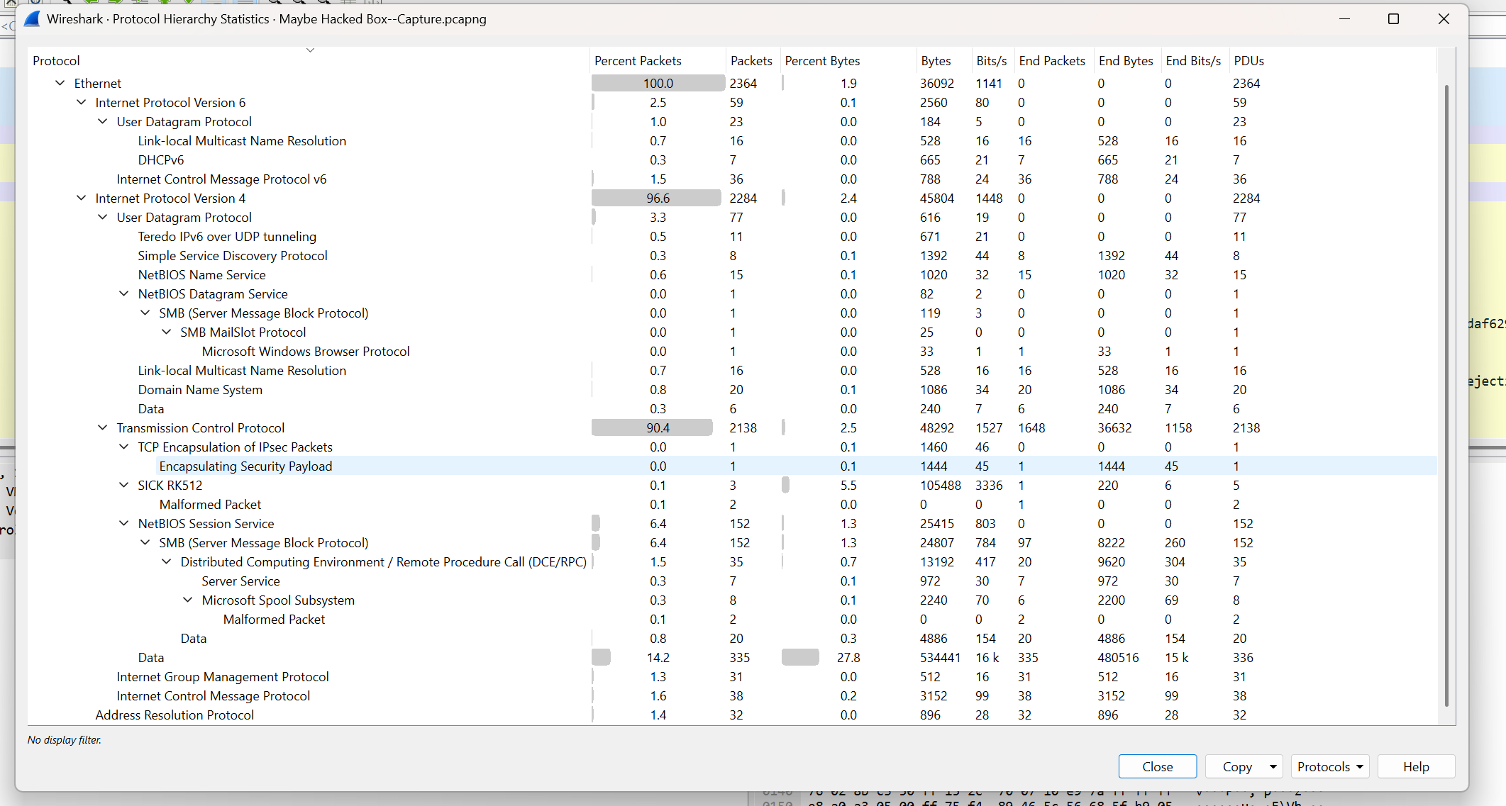
Figure 1:Protocol Hierarchy
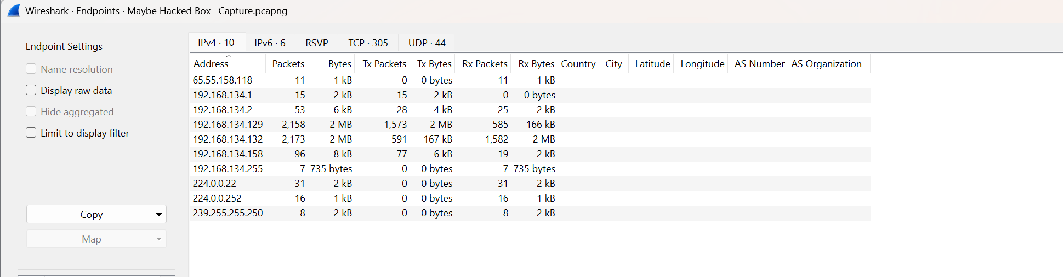
Figure 2: Endpoints
2.1.2. Network Reconnaissance
The attacker conducted extensive reconnaissance of the victim's network, as evidenced by the following activities:
•Port Scanning: The attacker's machine scanned over 300 unique TCP ports on the victim machine. The scanned ports include common services such as HTTP (80), SMB (445), RDP (3389), and various database ports. This indicates an attempt to identify other vulnerable services for potential exploitation.

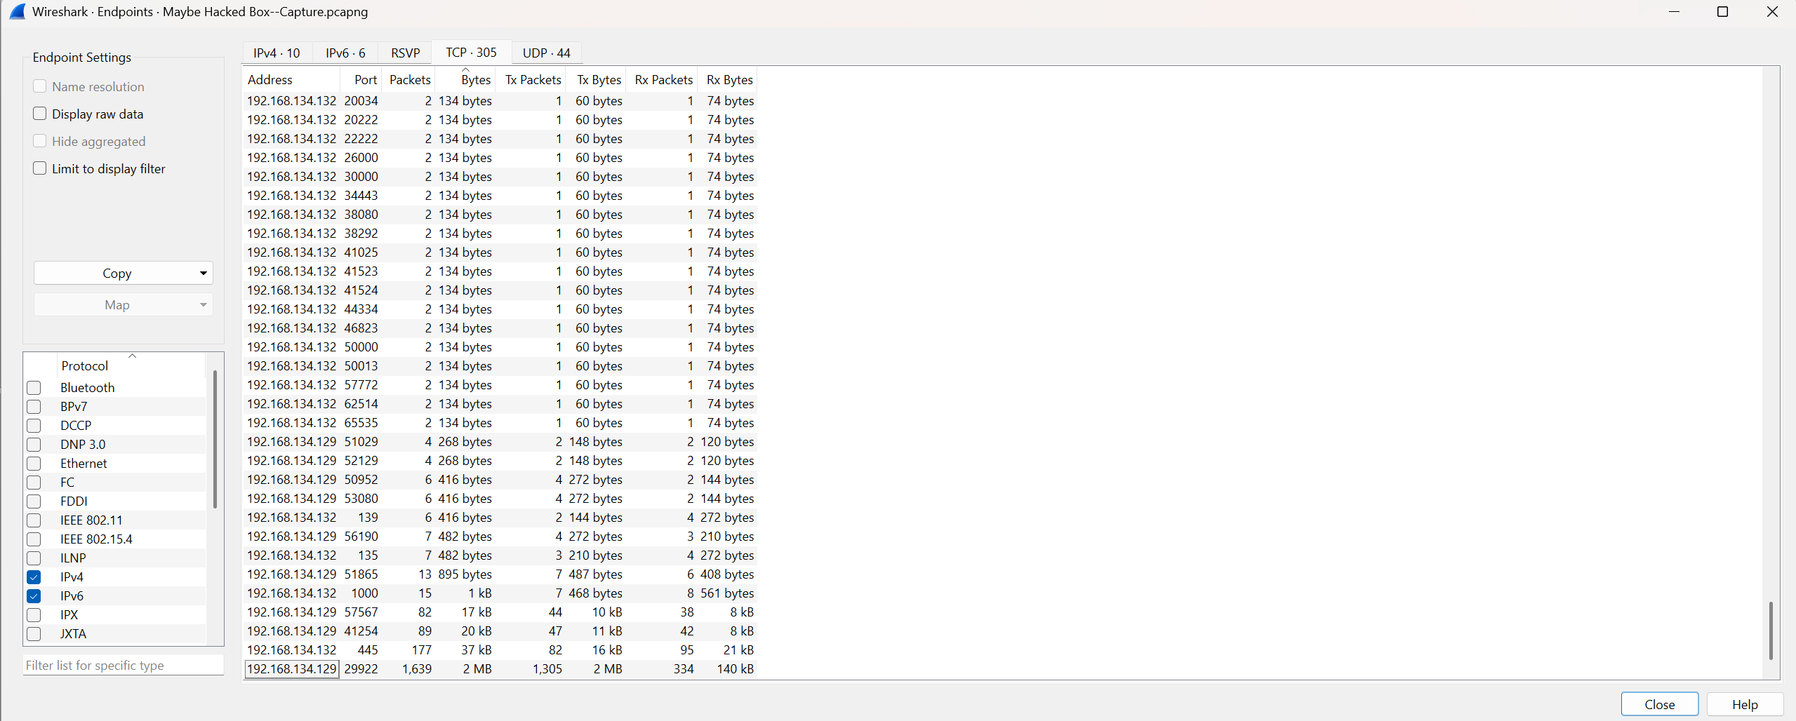
Figure 3: Conversation between TCPs
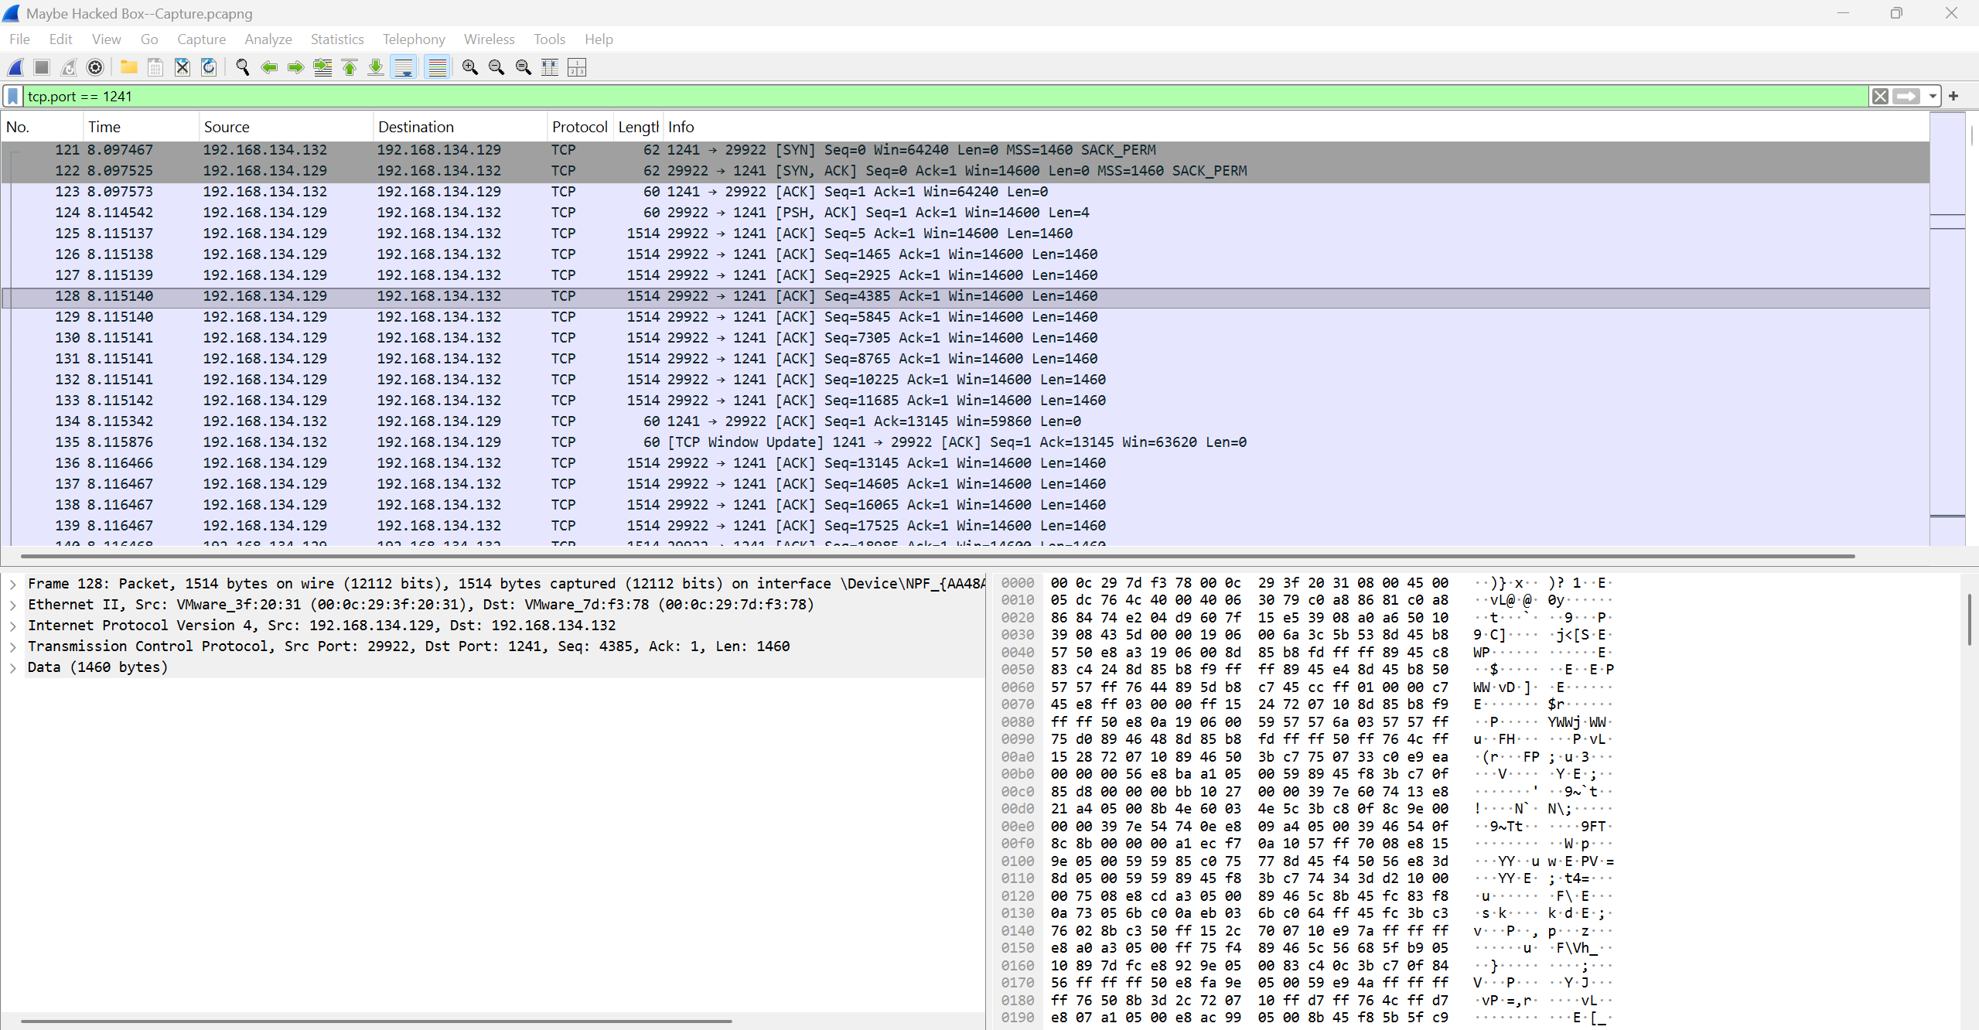
Figure 4: TCP==1241 Filter (Poison Ivy)

•SMB Enumeration: The attacker accessed the IPC$ share on the victim machine and enumerated named pipes such as SRVSVC, BROWSER, and SPOOLSS. This is a common technique for gathering information about a system and preparing for lateral movement.

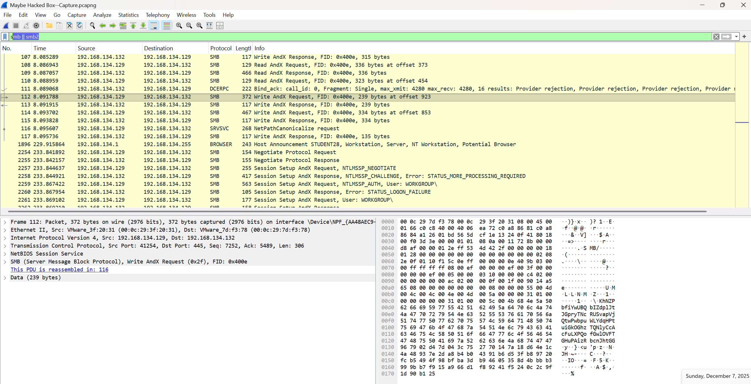
Figure 5: SMB Filter
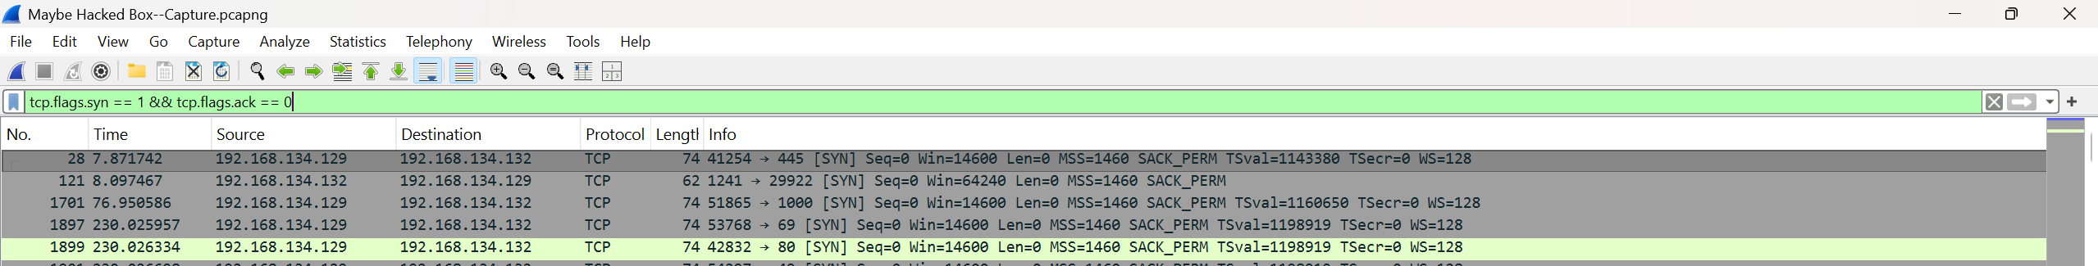
Figure 6: TCP SYN packets (port scan detection)
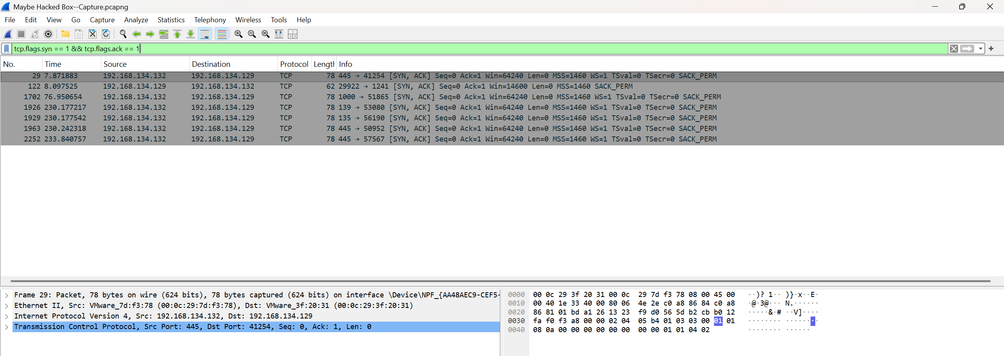
Figure 7: TCP SYN-ACK packets (open ports)
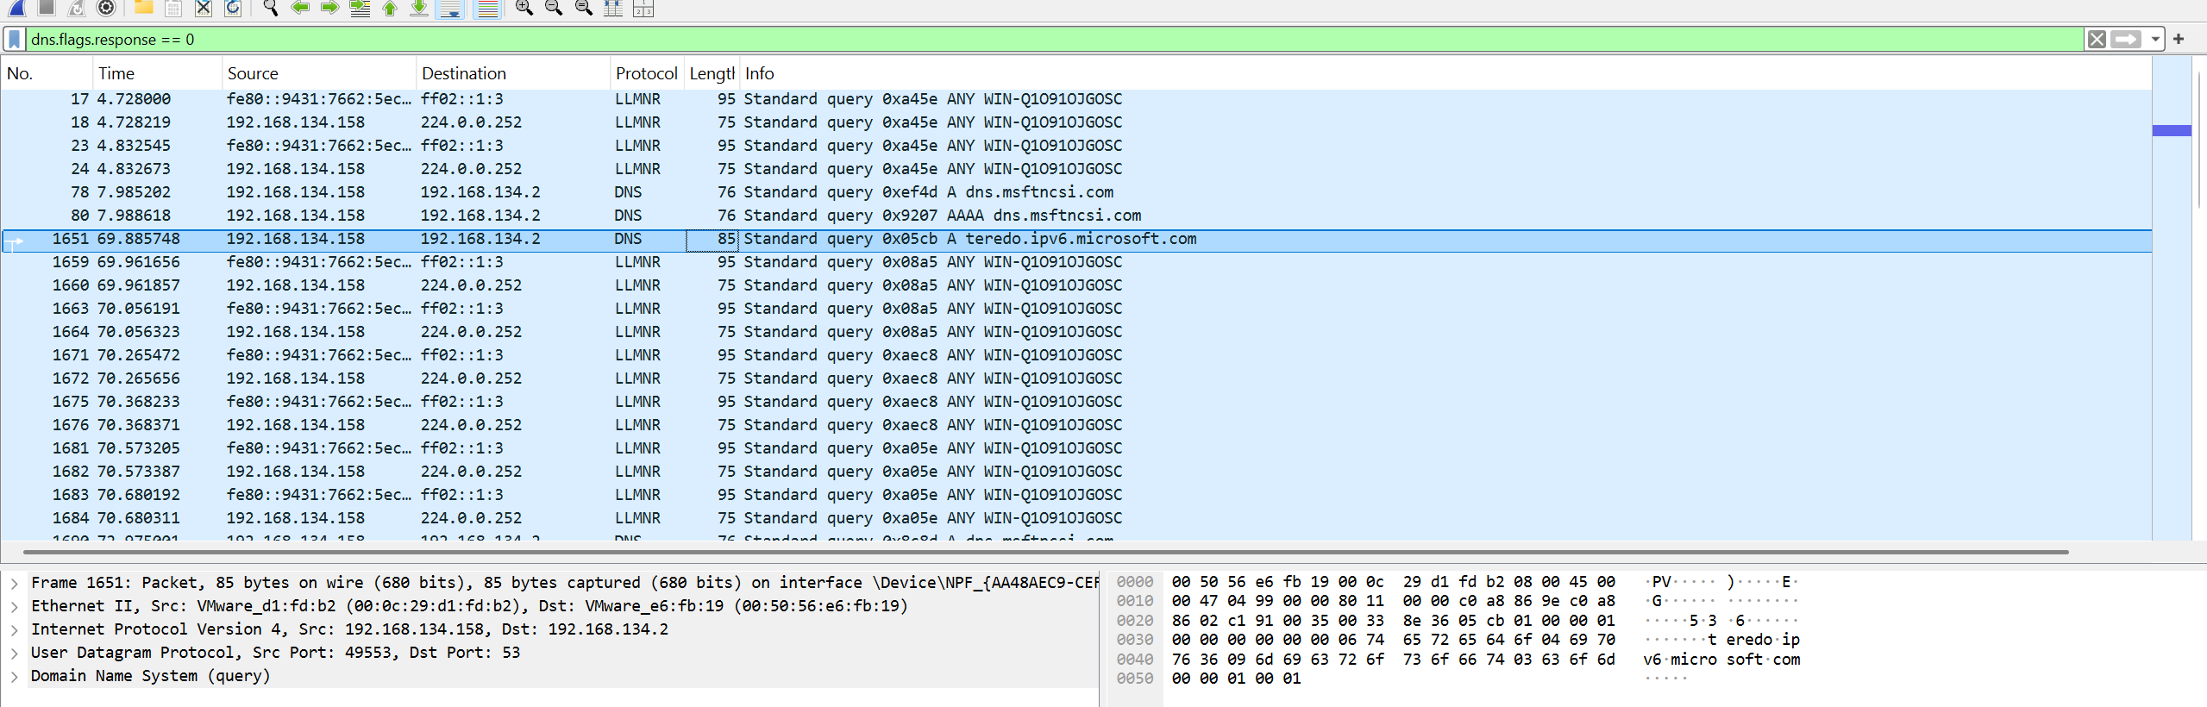
Figure 8: DNS queries
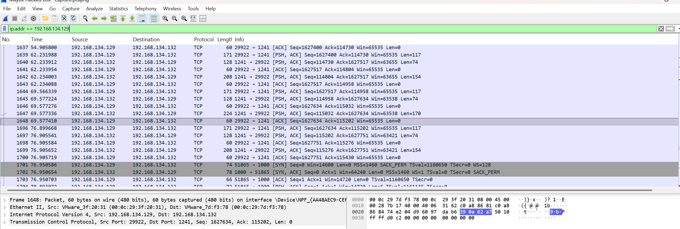
Figure 9: Traffic to/from attacker IP
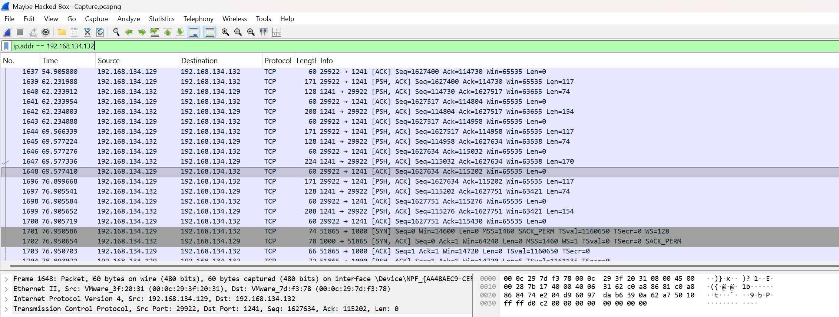
Figure 10: all traffic to/from victim IP
2.2. Event Log Analysis
The provided Windows event logs (ApplicationLog.evt and SecurityLog.evt) were analyzed for signs of compromise. The logs contained a total of 110 application events and 192 security events. The analysis of these logs did not reveal any direct evidence of the intrusion. The events appeared to be related to normal system operations, such as service start/stop events and network connectivity checks. The absence of suspicious log entries could be due to several factors, including the stealthy nature of the malware, the recentness of the attack, or the possibility that the attacker cleared the logs.
3. Attack Timeline and Correlation
By correlating the network traffic analysis with the characteristics of the Poison Ivy RAT, the following attack timeline was reconstructed:
Time (EDT) | Event | Description
15:09:37 | Initial Network Activity | The attacker resolves the victim's hostname and checks for network connectivity.
15:09:40 | SMB Enumeration | The attacker connects to the victim's machine via SMB and enumerates named pipes.
15:09:40 | C2 Channel Established | A TCP connection is established on port 1241, the default for Poison Ivy.
15:09:40 - 15:12:00 | Malware Payload Delivery | Approximately 1.7 MB of data is transferred from the attacker to the victim.
15:09:40 - 15:13:30 | Port Scanning | The attacker scans over 300 TCP ports on the victim's machine.
15:10:42 | IPv6 Tunneling Activity | Teredo tunneling activity is observed, potentially for C2 communication.
4. Indicators of Compromise (IOCs)
The following IOCs were identified during the investigation and can be used for threat hunting and detection:
•Network IOCs:
•C2 IP Address: 192.168.134.129
•C2 Port: 1241/TCP
•Suspicious DNS Queries: Queries for teredo.ipv6.microsoft.com
•Host-based IOCs:
•Malware: Poison Ivy RAT
•Persistence: Check for suspicious services, registry run keys, and scheduled tasks.
5. Impact Assessment
The successful deployment of the Poison Ivy RAT on the victim's machine poses a high risk to the organization. The attacker has the potential to:
•Steal sensitive data: Including user credentials, financial information, and intellectual property.
•Maintain persistent access: The RAT allows the attacker to maintain a foothold in the network for future attacks.
•Move laterally: The attacker can use the compromised machine as a pivot point to attack other systems on the network.
•Deploy additional malware: The attacker can use the RAT to deploy other malicious tools, such as ransomware.
6. Conclusion
The evidence gathered during this investigation strongly indicates that the system WIN-Q1O91OJGOSC (192.168.134.132) was compromised by the Poison Ivy Remote Access Trojan. The attacker successfully established a command and control channel and conducted network reconnaissance. The full extent of the data exfiltration and the attacker's activities on the compromised system could not be determined from the evidence provided alone. Further investigation, including memory and disk forensics, is required to fully understand the scope of this breach.
7. Recommendations
Based on the findings of this investigation, the following recommendations are provided to remediate the current incident and prevent future attacks.
7.1. Immediate Remediation
1.Isolate the Compromised System: Immediately disconnect the affected machine (192.168.134.132) from the network to prevent further malicious activity.
2.Preserve Evidence: Create a forensic image of the system's memory and hard disk for further analysis.
3.Block Malicious IP: Block the attacker's IP address (192.168.134.129) at the firewall.
4.Reset Credentials: Reset all user and service account passwords that were used on the compromised system.
7.2. Long-Term Prevention
1.Network Segmentation: Implement network segmentation to limit the attacker's ability to move laterally.
2.Endpoint Security: Deploy and maintain an endpoint detection and response (EDR) solution to detect and block malware like Poison Ivy.
3.Security Awareness Training: Educate employees about the dangers of phishing and other social engineering attacks.
4.Vulnerability Management: Implement a robust vulnerability management program to ensure that systems are patched and up-to-date.

